Cubed Croissants

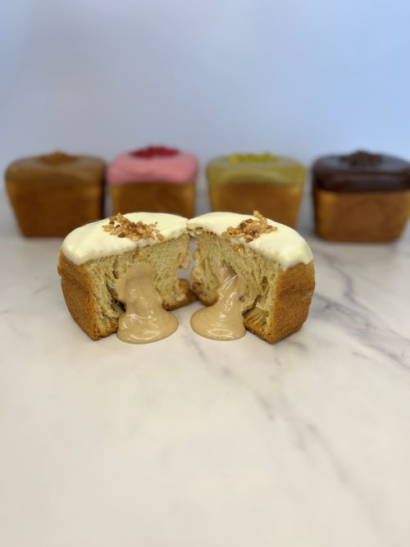
Ingredients:

Carr’s Baker’s Strong Flour 1.900Kg

Salt 0.040Kg

Sugar 0.100Kg

Cold Water (-5°C) 1.100Kg

Yeast 0.120Kg

Milk Powder 0.150Kg

Crispuff Pastry Margarine 0.900Kg

Method:
- To make the pastry dissolve the yeast in the cold water, and then add to all the other ingredients (except the Crispuff Pastry Margarine).

Mix for 5 minutes on medium speed

Roll the dough out, then cover half of the dough with Crispuff Pastry and Margarine, fold over the remaining dough so as to cover all the margarine

Give the dough 3 half turns

Pin down to 15mm, cover with plastic, then rest in the freezer for 20 minutes (ideal dough temperature -11°C to - 12°C)

After 20 minutes rest, proceed to finish as required

Cut the pastry into 6cm (width) strips and 75cm (length)

Roll width way

Place into square tin and place another tin on top with a heavy oven proof object on top to stop the dough from over flowing

Bake at 160°C for 50 minutes

Fill the croissants with chosen filling

Dip croissant into chosen topping and decorate

Our chosen flavours:

White Coverdecor filled with IRCA Nocciolata Bianca

Macphie 5th Avenue Caramel filled with Biscoff

Strawberry Coverdecor filled with Mactop Extra

Coated and filled with Crema Vela Pistachio

