French Martini Panna Cottas

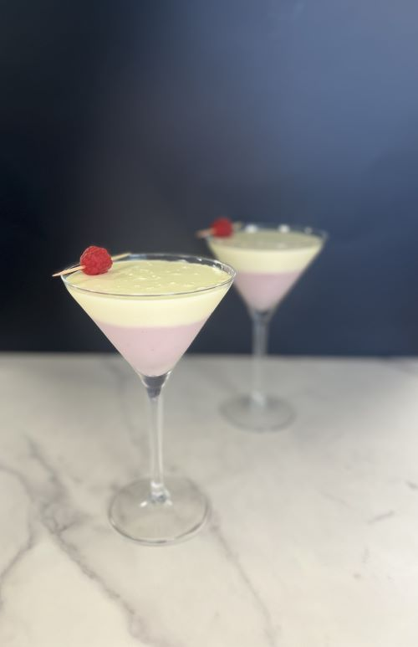
Ingredients:

Macphie Panna Cotta 1.000L

Braun Dessert Paste Raspberry 2 tsp

Braun Dessert Paste Pineapple 1 tsp

Raspberries

Method:

Add 750ml Panna Cotta to a saucepan, bring to the boil, stirring continuously.

Mix in the raspberry dessert paste and pour into martini glasses until ¾ full and allow to set in the fridge

Pour the remaining 250ml of Panna Cotta into a saucepan, bring to the boil, stirring continuously

Mix in the pineapple dessert paste and pour into the martini glasses on top of the set raspberry Panna Cotta, allow to set and garnish with a raspberry and serve

